**OOAD Project: Final Report**

**MENTAL HEALTH CHATBOT**

Team Members

Name: Hitesh Dhiman

Enrolment No: 22114036

Mail Id: hitesh_d@cs.iitr.ac.in

Contact No: 8580558575

Contribution: Backend and AI training

Name: Indranil Das

Enrolment No: 22114037

Mail Id: indranil_d@cs.iitr.ac.in

Contact No: 8902031812

Contribution: AI training and dataset collection

Name: Kakumani Kushalram

Enrolment No: 22114043

Mail Id: kakumani_k@cs.iitr.ac.in

Contact No: 7801032609

Contribution: Backend

Name: Piyush Gokul Chavan

Enrolment No: 22114024

Mail Id: chavan_pg@cs.iitr.ac.in

Contact No: 9422900151

Contribution: Frontend

Name: Nithin Nathanael

Enrolment No: 22114023

Mail Id: bolapati_nn@cs.iitr.ac.in

Contact No: 9393997777

Contribution: Frontend

Name: Sadineni Chaitanya

Enrolment No: 22114082

Mail Id: sadineni_c@cs.iitr.ac.in

Contact No: 9381194628

Contribution: Frontend

**Project Description**

Mental health is of utmost importance in the professional realm as it underpins personal well-being and significantly influences productivity, job satisfaction, and overall workplace dynamics.

It enhances one's ability to navigate stress, regulate emotions, and cultivate positive relationships, fostering a more cohesive and supportive work environment.

By prioritizing mental health in a professional context, organizations can reduce absenteeism, improve job satisfaction, and create a more positive and productive atmosphere, benefitting both individuals and the company.

Our Mental Health FAQ Chatbot represents a user-centric and interactive platform dedicated to addressing commonly encountered questions surrounding the realm of mental health.

Employing a meticulously curated database and advanced natural language processing prowess, the chatbot excels in furnishing timely and precise responses to an extensive spectrum of inquiries.

**Key Features of the Mental Health FAQ Chatbot Include:**

**Comprehensive FAQ Database:**

Our chatbot boasts an extensive FAQ database covering a wide array of mental health topics. We diligently update it with the latest research findings and best practices to ensure its relevance and accuracy.

**User Friendly Interface:**

Build a responsive and user-friendly chatbot accessible via web browsers on laptops and PCs.

Design an accurate and comprehensive database of questions and answers on mental health.

**Supplying Assessment queries to users:**

Our chatbot engages users with tailored queries, employing their responses to conduct a technical assessment of their mental health status, subsequently delivering an analysis-based result.

**Safeguarding confidentiality:**

The privacy of the user will be secured and if the user is not

comfortable on giving any personal information, there

will be an option to stay anonymous.

Our Mental Health FAQ Chatbot is a reliable and comprehensive resource designed to empower users on their mental well-being journey. It provides accurate, accessible information and a personalized touch, ensuring that individuals have the knowledge and resources they need to make informed decisions regarding their mental health.

**Problems Encountered with Chatbot**

In undertaking the development of our mental health chatbot, we were driven by the imperative need for accessible and precise mental health information and support. However, our path was not without its intricacies.

Data privacy and security were paramount concerns, leading to the implementation of robust measures to safeguard user data throughout interactions with the chatbot. The technical challenge of seamlessly integrating our chatbot into diverse digital platforms required meticulous engineering and a keen eye for user experience. Furthermore, ensuring the continuous accuracy and relevance of our database called for ongoing research and curation efforts.

Our development approach emphasized rigorous testing and iterative refinement to deliver personalized and dependable user interactions. Overcoming these challenges has resulted in the creation of a technically advanced and highly secure solution that effectively addresses the critical demand for reliable mental health resources.

Our chatbot now stands as a testament to our unwavering commitment to making mental health support and information readily available to those who need it.

**Reasons, Problems Encountered**

Analysing mental health in current times is essential for several reasons, and our chatbot efficiently addresses these needs.

**Remote access:**

The COVID-19 pandemic highlighted the need for remote mental health support. Our chatbot, available on websites, provides accessible and remote assistance to users seeking help from the comfort of their homes.

**Early Intervention:**

Identifying mental health issues early is crucial. Our chatbot can detect early warning signs and offer resources or recommend professional help.

**Anonymity:**

Many individuals prefer discussing their mental health concerns anonymously. Our chatbot allows users to share their thoughts and feelings in a confidential and non-judgmental environment.

**Implementation and why?**

**HTML (Hyper Text Markup Language)**

1) HTML structured the webpage, defining the chatbot interface layout and content organization.

2) It created input forms and ensured the framework for user-friendly interactions.

3) HTML played a foundational role in the structure of the chatbot integration.

**CSS (Cascading Style Sheets)**

1) CSS customized the chatbot's appearance, including fonts, colours, and layout.

2) It maintained a consistent and visually appealing design throughout the chatbot interface.

3) CSS harmonized with the website's visual identity, enhancing the overall aesthetic.

**JS (JavaScript)**

1) JavaScript added dynamic interactivity, enabling real-time user interactions with the chatbot.

2) It facilitated instant response rendering and engaging animations.

3) JavaScript enhanced the user experience by making the chatbot integration highly responsive and interactive.

**Django framework in Python**

**High Level Web Framework**

Django is a high-level web framework that simplifies web development with its "batteries-included" approach.

**ORM (Object Relational Mapping)**

Django includes a robust Object-Relational Mapping system, allowing developers to work with databases using Python objects.

**Admin Interface**

Django offers a built-in admin interface that simplifies content management for developers and website administrators.

**Chatterbot Library**

**Conversational AI Framework**

Chatterbot is a Python library designed for creating chatbots and conversational agents.

It provides a straightforward and customizable solution for building AI-driven chatbot applications.

**Training and Machine Learning**

Chatterbot supports training chatbots using machine learning algorithms such as Naive Bayes and deep learning models.

It allows chatbots to learn from conversations and improve their responses over time.

**Extensibility and Customisation**

Chatterbot is highly extensible and customizable, allowing developers to fine-tune chatbot behaviour.

Developers can add custom logic and functionalities to tailor Chatterbot to specific applications.

**Bootstrap**

**Frontend development framework**

Bootstrap is a popular front-end development framework that simplifies web design and development.

It provides a set of pre-designed, responsive components and styles, making it easier to create modern and mobile-friendly web applications.

**Responsive Design and Grid system**

Bootstrap includes a responsive grid system, allowing developers to create flexible and adaptive layouts for various screen sizes.

It ensures that web applications look and function well on desktops.

**Community and Ecosystem**

Bootstrap benefits from a large and active community, providing access to a wealth of resources, themes, and plugins.

The ecosystem around Bootstrap offers pre-built solutions and templates for faster development.

Bootstrap is a well-supported framework that streamlines front-end development and helps maintain design consistency.

**Use Case Diagram:**

**Flowchart:**

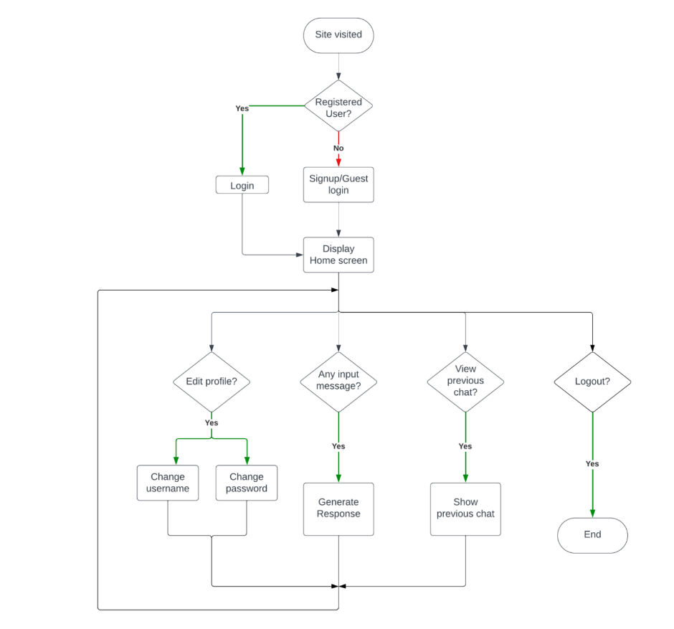

**Sequence diagram:**

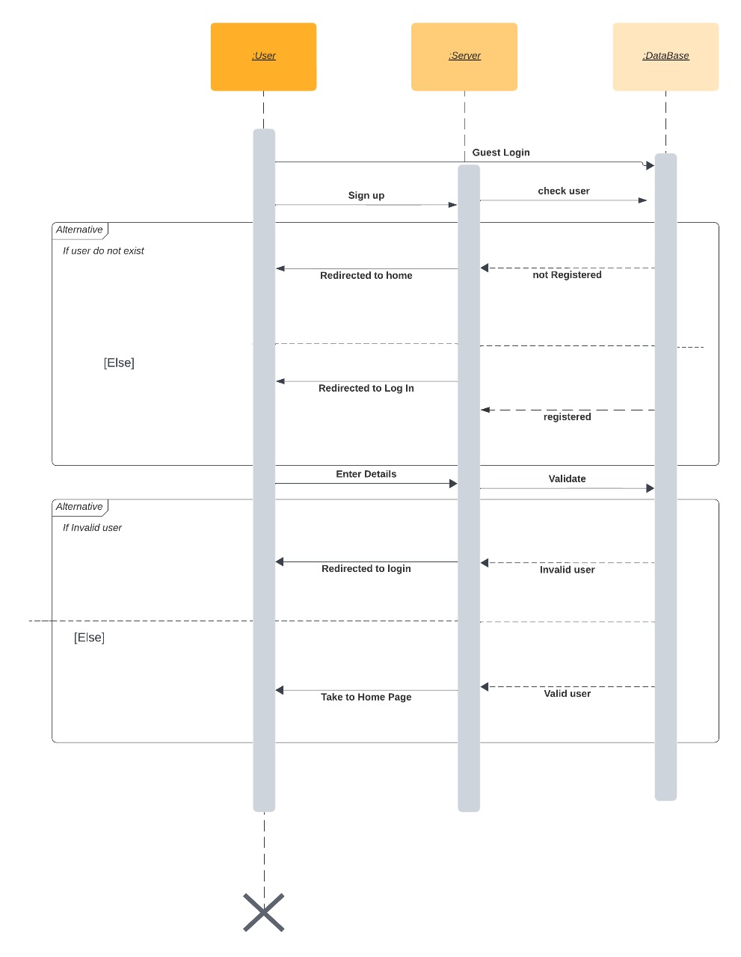

**Sign in/Sign up sequence**

Start New discussion

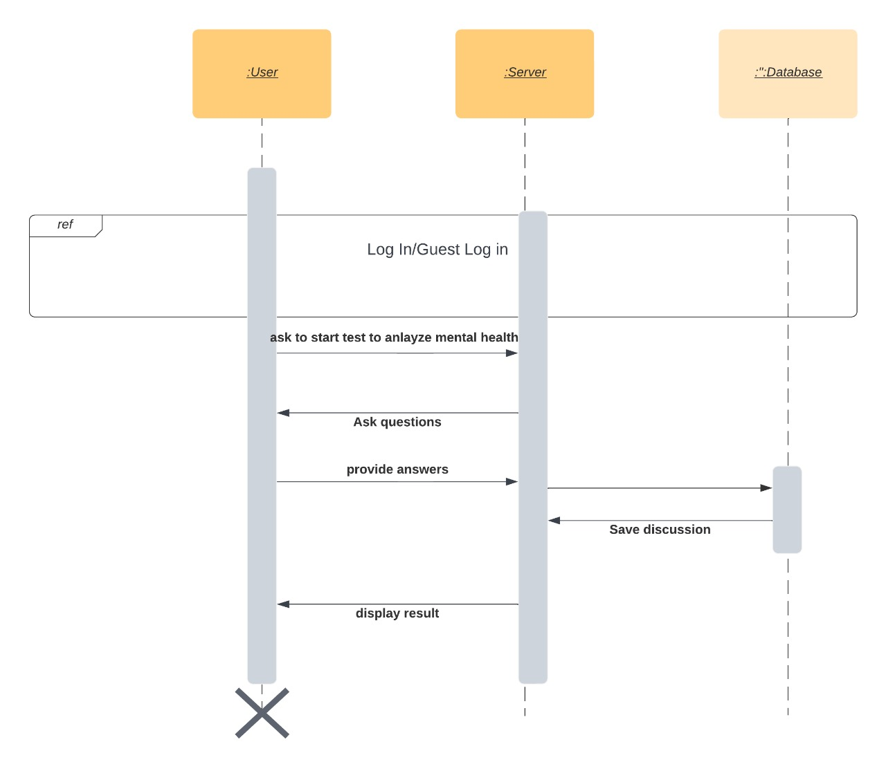

Analysing Mental Health

**Future Scope of Project:**

* Integration of advanced NLP for more empathetic and personalized interactions.
* Expansion of mental health assessments to encompass a wider range of conditions.
* Implementation of real-time data analysis for instant feedback and customized resources.
* Introduction of a virtual support community to foster peer-to-peer interaction and shared experiences.
* Incorporation of telemedicine features for users to connect with mental health professionals remotely.
* Focus on research and development to leverage AI-driven predictive analytics for proactive interventions and preventive measures.
* Continuous improvement of the platform's technological capabilities to ensure long-term user engagement and support.

**Conclusion:**

our mental health chatbot offers FAQ responses, conducts tests on depression, anxiety, stress, and PTSD using established forms like PHQ-9 and GAD-7, and securely stores chat histories for registered users. User confidentiality is prioritized, as chat records are not saved for guest users. Our platform provides accessible and personalized mental health support, fostering a safe space for individuals to seek guidance and improves their well-being.